http://cathnews.com/cathnews/21509-catholic-trust-looks-to-brazilian-fund-for-social-returns

A Catholic trust looks to a Brazilian fund for social returns
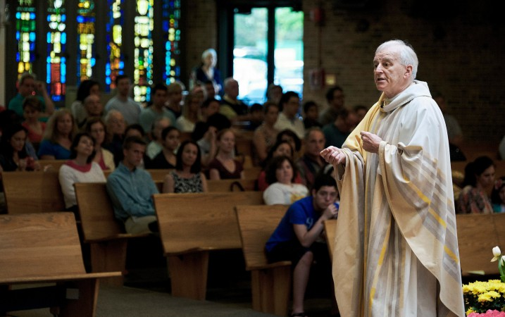
Friar Seamus Finn helps run a trust that manages the assets of more than 230 Roman Catholic congregations in 53 countries. (Photo by T.J. Kirkpatrick for The New York Times)
By Vinod Sreeharsha
New York Times News Service May 22, 2015
RIO DE JANEIRO — A Brazilian investment fund is taking to heart the Vatican’s endorsement of leveraging capitalism’s tools to help address inequality.
An investment firm, First, is on track this year to raise the country’s largest so-called impact investing fund, which is aimed at promoting social good as well as profitable returns. And it is being supported by some big players like JPMorgan Chase and the World Bank’s private investment arm.
First is also being backed by an even higher power: a trust established by a 199-year-old international order of the Roman Catholic Church.
The capital provided by the Oblate International Pastoral Investment Trust is its initial investment in a Brazilian impact fund. The amount, about $7 million, may seem small, but it reflects the growing interest in the sector by Catholic groups worldwide. And for the Catholic Church, the concept seems to dovetail with Pope Francis’ focus on finding ways to address inequality.
Ensuring that faith-based investments are consistent with Catholic values has long been difficult. But many people increasingly see what is called impact investing — which measures both financial and social returns — as one way to do so. Not only are investment gains important, but the fund also gauges whether its investments are providing social improvements, such as in education, health care or the environment. This asset class is making inroads in Brazil, home to the world’s largest Roman Catholic population.
First’s fundraising, if successful, would be a watershed moment in Brazil, even though it has taken several years to get started. It is expected to soon surpass 300 million reais, or $98 million, and hit its $125 million target this year, according to a person briefed on the fund’s activities. The $98 million would be more than half of the cumulative $177 million raised by all other impact funds in Brazil from 2004 to 2013, according to a report last year by the Aspen Network of Development Entrepreneurs.
The firm attracted the attention of the Oblate trust, which was established by the Missionary Oblates of Mary Immaculate. The trust manages the assets of more than 230 Roman Catholic congregations in 53 countries and holds about $400 million.
The trust’s chief of faith-consistent investment is Friar Seamus Finn, a 65-year-old Ireland native who offers weekend Mass at a parish in Washington, where he lives. Finn, who travels to Brazil roughly once a year, said the trust’s participation reflected growing interest in impact investing.
It invested $35.5 million in such funds last year, more than double the $15.5 million it committed in 2013. Its percentage allocation nearly doubled as well. Finn said he expected both numbers to continue increasing over the next two years.
“We feel we are much closer to the principles than we are at a global multinational,” he said.
Impact investing is growing globally. The number of organizations catering to interested investors rose 17 percent this year, during which they expect to invest $12.2 billion, which would be an increase of 16 percent from last year, according to a 2015 annual report on impact investing by JPMorgan and the Global Impact Investing Network. Bain Capital and the Blackstone Group announced new initiatives this year.
The Vatican has long spoken about the need for the markets to reduce inequality, from Pope Leo XIII in his 1891 encyclical Rerum Novarum on Capital and Labor to Pope Paul VI’s Populorum Progressio in 1967.
Yet Francis, the first pontiff from Latin America, has made this a top priority. He said last year, “It is increasingly intolerable that financial markets are shaping the destiny of peoples rather than serving their needs.”
Moreover, the pope has discussed impact investing with unusual specificity.
He gave a private address last June to a group attending a two-day conference in Rome on impact investing, co-organized by the Vatican’s Pontifical Council for Justice and Peace. Church treasurers as well as finance heavyweights, including executives from Goldman Sachs and Bank of America Merrill Lynch, attended. In those remarks, Francis lauded the sector, saying, “Impact investors are those who are conscious of the existence of serious unjust situations, instances of profound social inequality and unacceptable conditions of poverty affecting communities and entire peoples.”
Faith-based investing has been a part of many religions. Islamic financing goes back centuries and has grown in recent decades. The Dow Jones Islamic Market Indexes that screen for compliance with Shariah law were started in 1999. The United Methodist Church holds $21 billion in assets and has invested in 5,000 companies.
The investment strategy has recently shifted, however, away from what has long been an exclusionary approach.
For example, the Oblate trust — which largely invests in public equities and fixed income — uses what it calls negative screening. It prohibits investing in companies that develop assault weapons and handguns, or those that are involved in controversies over labor rights. But those rules do not provide a guide on what it should invest in. Impact investing helps in that regard.
“It suits and fits better with our desire to be constructive and look for positive impact investments rather than excluding things,” Finn said.
There are less lofty motivations as well. Finn said that impact investing was increasingly an important asset class in terms of diversifying and managing the group’s portfolio.
Ascension Investment Management, which manages the assets of the largest Catholic nonprofit health care system in the United States, is raising its first dedicated impact investing fund, looking to raise $50 million to $100 million. It expects to focus on food production, health care, and housing.
Catholic Relief Services has also recently set aside $5 million to invest in impact investing funds for the first time and expects to make its first investment this year. To date, it has met with six funds, said Patricia M. Dinneen, a former managing director at the private equity firm Siguler Guff & Co., who is leading the effort.
Catholic Relief Services is also playing an influential role in meeting with congregations in the United States to discuss impact investing.
Brazil — home to 123 million Roman Catholics, the most in the world, according to the Pew Research Center — is fertile ground for these investments.
“I see Brazil as contributing heavily to this effort,” said Dinneen, who helped start Siguler Guff’s BRIC private equity fund of funds before she retired.
Although Brazil has a mature finance sector and progress has been made over the last two decades, stark inequality remains. Sectors important to impact investors are some of Brazil’s most glaring weaknesses. Continuing macroeconomic problems could only amplify that.
“There is opportunity,” Finn said, noting “people are going to need those services and deliverables every day.”
To be sure, the shift to impact investing is likely to be gradual. The Oblate trust does not plan to replace its traditional investments overnight. In some cases, such as its investment in a HarbourVest Partners private equity fund, it seems satisfied.
And multiple challenges remain. One is an adequate pipeline of companies, especially those in the growth stage. The Aspen Network report noted that the average investment in Brazil was $1.1 million, indicating extremely early-stage investments.
Rebeca Rocha, the head of Brazil for the Aspen Network, said that although the number of impact investors in the country had tripled since 2012, “it’s very difficult to find a lot of entrepreneurs who have the right profile, understand social impact and have companies that can scale.” That could be an issue for the firm First, given its size.
The Catholic Church has faced divisive issues as well.
Many in Brazil and the region still have ties to liberation theology, which emphasized the poor, but also shared some aspects of Marxist philosophy and therefore opposed the US economic system and style of investing.
In the past, that view had some basis after several military dictatorships in Latin America received backing by the US government. The region is much different today, but Finn said he expected some doubters.
“Some folks will push back and criticize this and say it is just another way of making the capitalist model look good,” he acknowledged, adding that he welcomed the scrutiny.
“It is important to not overstate what this can accomplish,” he said

